**Resonance Tube**

[Modified from PASCO lab manual #58]

**Pre-lab questions:**

1. What is the goal of this experiment? What physics and general science concepts does this activity demonstrate?
2. A pipe organ uses multiple tubes of fixed length to create musical notes with different pitches. In a pipe organ, which pipes make the low notes, the long ones or the short ones.
3. How would a warmer temperature affect the fundamental frequency of the open tube of fixed length?
4. What would be the effect of performing this experiment in an atmosphere of helium?

**Equipment:**

* Open speaker
* Patch cords (set of 5)
* Resonance Tube
* Wireless temperature sensor

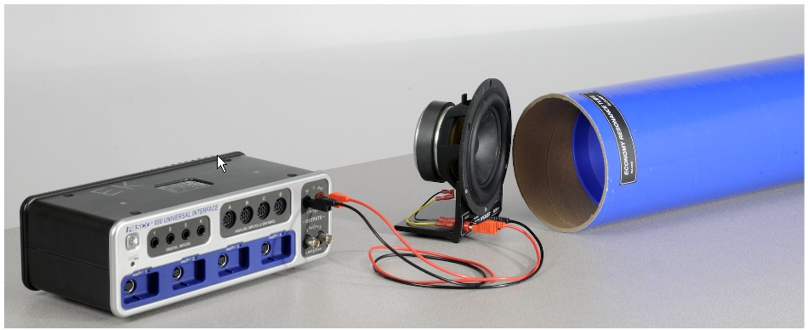

Figure 1: Resonance tube equipment.

The goal of the experiment is to explore resonance by creating a standing (sound) wave in a tube. The driving frequency and the length of the tube can be varied to study their relationship to wavelength and the speed of the sound wave. The concepts of nodes, anti-nodes, and harmonics will be investigated for both closed and open tubes.

**Introduction:**

A resonating tube with one end open and the other end closed will always have a node at the closed end and an anti-node at the open end. A node represents an area where the velocity of the air is a minimum (zero), and an anti-node represents an area where the velocity of the air is a maximum. If the tube is resonating at a particular fixed frequency, the tube will resonate as shown below, where the curved lines represent the velocity profile of the air in the tube.

As the length of the active part of the tube is increased, the sound becomes loud at each successive node and quiet at the antinodes. Note that the distance between the nodes is ½ λ.

For all types of waves, the frequency (f) and the wavelength (λ) are related to the speed (v) of the wave as given by Equation 1.

$$\begin{aligned}v=λf\#\left(1\right)\end{aligned}$$

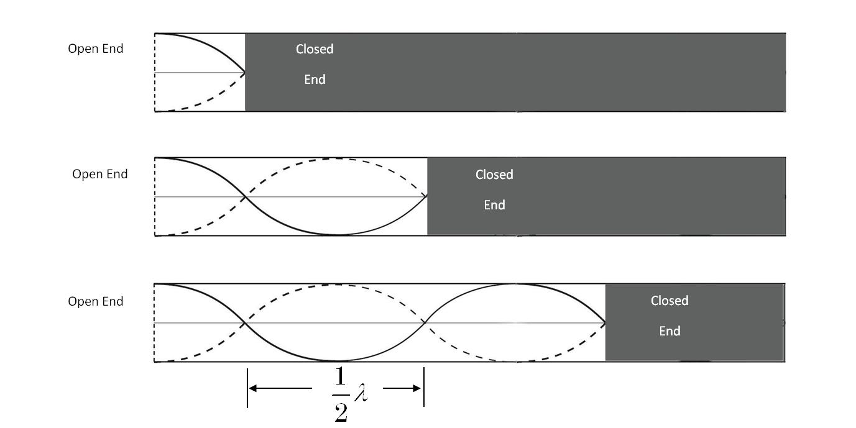

Figure 2: Modes of vibration in a closed tube of variable length.

A resonating tube with both ends open will always have an anti-node at both ends, and at least one node in between. The number of nodes is related the wavelength and the harmonic. The first harmonic (or fundamental) has one node, the second harmonic has two, etc., as shown here. For a tube of fixed length, at higher harmonics, the frequency is higher and the wavelength is shorter.

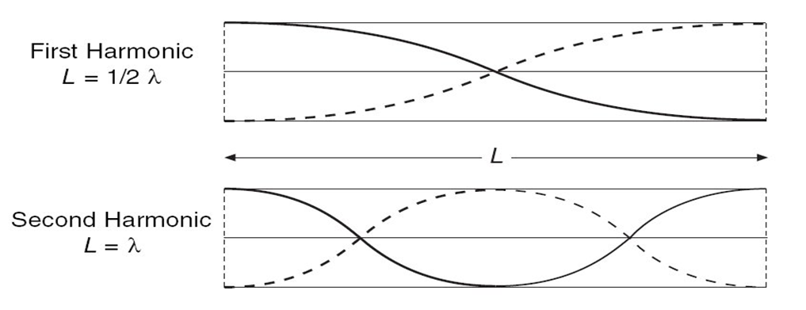

Figure 3: Modes of vibration in an open tube of fixed length.

## Experiment:

***Set up***

* In PASCO Capstone, open the Hardware Setup and click on Signal Generator #1 on the 850 Interface and select the Output Voltage Current Sensor.

* Click on the Signal Generator at the left of the screen and open the controls for 850 Output 1. Set the sine wave amplitude to 0 volts.
* Connect Output 1 on the interface to the speaker using two banana patch cords. Polarity does not matter.
* Place the Resonance Tube horizontally, as shown, with the speaker near the open end. Place the speaker at a 45° angle to the end of the tube, not pointed directly into it.
* The inner (white) tube slides inside the blue tube to adjust the effective length of the closed tube.
* Connect the Temperature Sensor to any of the *PASPORT* inputs on the interface and connect the temperature probe to the sensor.
* Create a Digits Display and select the Temperature.

***Procedure – Closed Tube of Variable Length:***

* Slide the two tubes together, so that the tube length is zero. Open the Signal Generator at the left. Set the frequency for 300 Hz and the amplitude on a reasonable level.
* Extend the white tube, increasing the tube length. The loudness of the sound will noticeably increase as you approach resonance. Move the tube in and out to pinpoint the position that gives the loudest tone. Record this position.
* Continue extending the white tube to find all the positions that cause a resonance. Each of these positions represents a node in the standing wave pattern.
* Set the Signal Generator frequency for 400 Hz and repeat the above procedure.

**Data - *Closed Tube of Variable Length:***

Create a table and record node positions for frequency of 300 Hz.

Create a table and record node positions for frequency of 400 Hz.

Record air temperature.

**Computations, and Analysis - *Closed Tube of Variable Length*:**

* Calculate the distance between the nodes for the 300 Hz wave, and take the average if you have more than one value. Use this distance to calculate the wavelength of the sound wave.
* Repeat the above calculation for the 400 Hz wave.
* Use the frequency of the sine wave generator to calculate the speed of the wave for both the 300 Hz and 400 Hz wave.
* How does the speed of the wave at 400 Hz compare to the previous wave at 300 Hz?
* The actual speed of the wave is the speed of sound in air, which is temperature dependent. This theoretical value can be calculated using

v = 331 m/s + 0.6 T

where T is the temperature of the air in degrees Celsius. Use the measured air temperature to calculate the speed of sound.

* Compare your measured values for the speed of sound to the actual value. Calculate the percent deviation.

$\% Error=\frac{\left|Actual-Experimental\right|}{Actual}×100\%$

***Procedure – Open Tube of Fixed Length:***

* Slide the inner tube all the way out, and separate it from the outer tube. Use only the outer blue tube with two open ends.
* Set up the Signal Generator and the speaker as before. Start with the frequency at 50 Hz and slowly increase it. Find the frequency of the fundamental (to the nearest 1 Hz).
* Increase the frequency of the Signal Generator and determine the frequency of the second and third harmonic. How do these compare to the fundamental?

**Data - *Open Tube of Fixed Length:***

Record frequency of the fundamental, second, and third harmonic.

Record air temperature.

Record length of tube.

**Computations, and Analysis - *Open Tube of Fixed Length*:**

* Calculate the wavelength using the frequency and the actual speed of sound you calculated in Part I. How does this compare to the length of the tube?

**Conclusions:**

Summarize the differences between an open and closed tube. Also discuss:

* How the velocity, wavelength, and frequency changed as the tube length was varied.
* How the velocity, wavelength, and frequency changed for the part of the experiment in which the tube length was constant.

**Sources of errors:**

What assumptions were made that caused error? What is the uncertainty in your final calculation due to measurement limitations?